8-56

Main Question (สำหรับแสดงข้อสอบ)

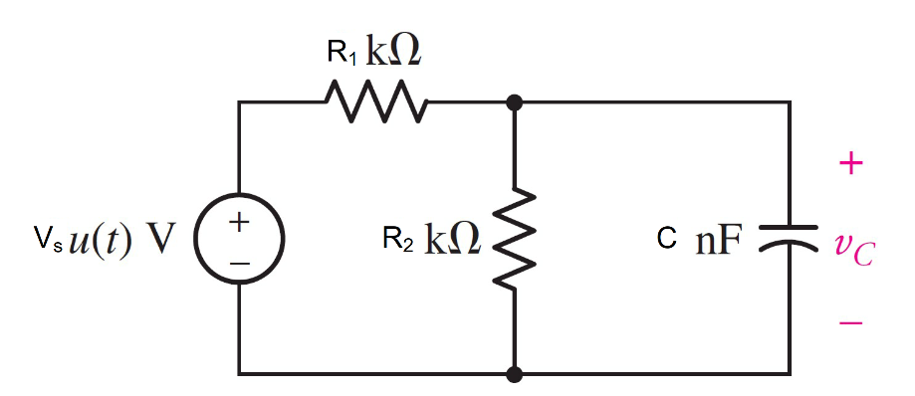

Given*Vs* = 3 *u(t)* V, *R*1 = 2000 Ω, *R*2 = 1000 Ω, C= 1 nF.

Find

Variables (สำหรับเขียนโค้ดเพื่อหาคำตอบ)

Random variables

vs = {1:5:};

r1 = {100:500:100};

r2 = {100:500:50};

c = {1e-9:5e-9:1e-9};

time = {1:5};

Global variables

#vs = 3; r1 = 2000; r2= 1000; c = 1*e(-9);

# t=0-

vc0 = 0;

# t=inf

vcf = (r1/(r1+r2))*vs;

# t=0+

req = r1*r2/r1+r2;

tau = c*req;

vct = vcf+(vco-vcf)*exp(-time);

wc = 0.5*c*vct*vct;

Part (กรอกคำตอบ)

1. *vc*(0-) = vc0 = 0 V
2. *vc*(∞) = vcf = 1 V
3. *τ* = tau = 0.6667x10-6 s
4. *vc*(*t*) = vcf+(vco-vcf)*exp(-t/tau)= 1-1*exp^(-t/0.6667x10-6)
5. *vc*(time*τ*) = vct = 0.632V *# time =1*

8-57

Main Question (สำหรับแสดงข้อสอบ)

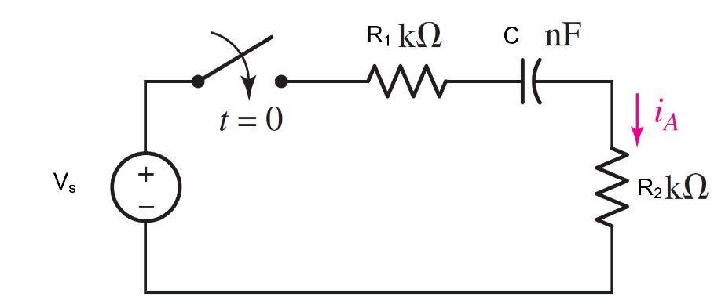

Given*Vs* = 10 V, *R*1 = 3000 Ω, *R*2 = 1000 Ω, C= 300 nF.

Find

Variables (สำหรับเขียนโค้ดเพื่อหาคำตอบ)

Random variables

vs = {1:10};

r1 = {1000:5000:1000};

r2 = {1000:5000:1000};

c = {100e-9:500e-9:100e-9};

time = {1:5};

Global variables

# vs = 10; r1 = 3000; r2= 1000; c = 300*e(-9);

# t=0-

vc0 = 0;

ia0n=0;

# t=inf

vcf = vs;

# t=0+

req = r1+r2;

tau = c*req;

vct = vcf+(vco-vcf)*exp(-time);

ia0p=vs/(r1+r2);

iat= ia0p*exp(-t/tau);

Part (กรอกคำตอบ)

1. *iA*(0-) = vc0 = 0 V

At *t* > 0

1. *vc*(∞) = vcf = 10 V
2. *τ* = tau = 1.2x10-3 s
3. *vc*(*t*) = vcf+(vco-vcf)*exp(-t/tau);= 10-10*exp^(-t/1.2x10-3) V
4. *iA*(*t*) = iat= 2.5*exp^(-t/1.2x10-3) V
5. *vc*(time*τ*) = vct = 6.32V *# time =1*

8-60

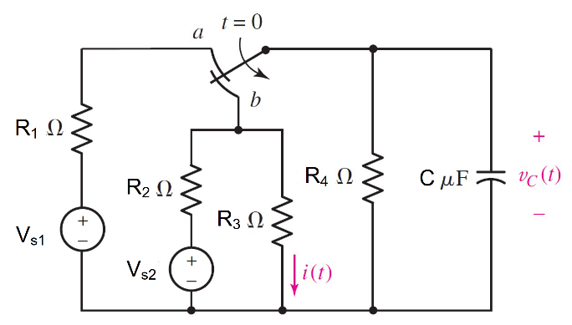

Given*Vs1* = 10 V, *Vs2* = 6 V, *R*1 = 5kΩ,

*R*2 = 10 Ω, *R*3 = 50 Ω, *R*4 = 20 kΩ, C= 2 µF.

Find

Variables (สำหรับเขียนโค้ดเพื่อหาคำตอบ)

Random variables

vs1 = {1:10};

vs2 = {1:10};

r1 = {1000:5000:1000};

r2 = {10:100:10};

r3 = {10:100:10};

r4 = {1000:20000:1000};

c = {1e-6:10e-6:1e-60};

time = {1:5};

Global variables

#vs1 =10; vs2 =6; r1 = 5000; r2= 10;

r3= 50; r4= 20000; c = 2*e(-6);

# t=0-

vc0 = (r4/r1+r4)*vs1;

i0n=;vs2/(r2+r3)

# t=inf

vcf = (r3*r4/(r3*r4+r2*r4+r2*r3))*vs2;

if = vcf/(r2+r3);

# t=0+

r23=r2*r3/r2+r3;

req = r23*r4/r23+r4;

tau = c*req;

vct = vcf+(vc0-vcf)*exp(-time);

wc = 0.5*c*vct*vct;

Part (กรอกคำตอบ)

1. *vc(0-) =* vc0 *=*8 V
2. *vc(0+) =* vc0 = 8 V
3. *vc*(∞) = vcf = 5 V
4. *τ* = tau = 16.66x10-6 s
5. *vc(t) =* vcf+(vc0-vcf)*exp(-t/tau) =5+3*exp^(-60x103t) V
6. *vc*(time*τ*) = vct = 6.1V *# time =1*
7. *wc*(time*τ*)  *=wc = 37.21 µJ # time =1*

8.62

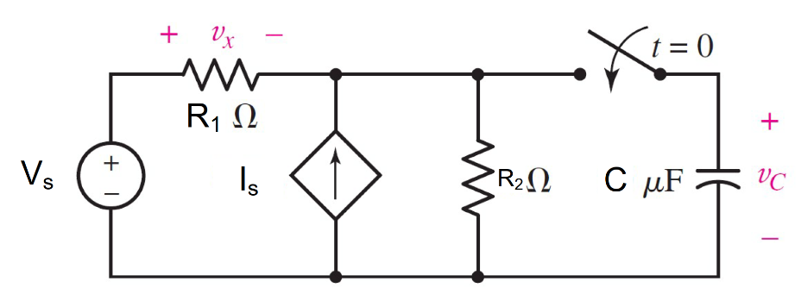

Given *Vs* = 3 V, *Is* = 0.5*Vx* A, *R*1 = 10Ω,

*R*2 = 5 Ω,C= 20 µF

Find

Variables (สำหรับเขียนโค้ดเพื่อหาคำตอบ)

Random variables

r1 = {10:100:10};

r2 = {1:20};

c = {10e-6:50e-6:10e-6};

vs= {1:5};

is= {0.5:5;0.5};

time = {1:5};

Global variables

#vs =3; r1 = 10; r2= 5;c = 20*e-6;

is =0.5

# t=0-

vc0 = 0

# t=inf

vcf = (r2+0.5*r1*r2/(r1+r2+0.5*r1*r2))*vs;

# t=0+

r23=r2*r3/r2+r3;

vth = (r1*r2)/(r1+r2+0.5*r1*r2);

req = vth/1;

tau = c*req;

vct = vcf+(vco-vcf)*exp(-time);

wc = 0.5*c*vct*vct;

Part (กรอกคำตอบ)

1. *vc(0-) = vc0* = 0 V
2. *vc*(∞) *=vcf = 2.25* V
3. *τ* = tau *=*25*e-6 s
4. *vc(t) =* vcf+(vco-vcf)*exp(-t/tau) =2.25-2.25*exp^(40x103t) V
5. v*c*(time*τ*) = vct = 1.422V *# time =1*
6. *wc*(time*τ*)  *=wc = 20.22 µJ # time =1*